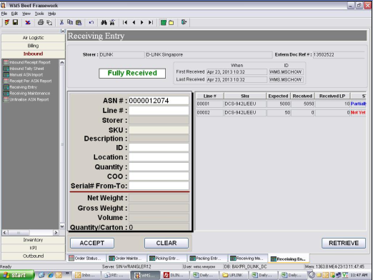
System to validate receiveing by line # & per line Expected Qty. DO NOT allow excess receiving. Current validate by total Qty.

